SQL Assignments

EMP Table Structure:

Name Null? Type

EMPNO NOT NULL NUMBER(4), Primary Key ENAME VARCHAR2(10)
JOB VARCHAR2(9)
MGR NUMBER(4)
HIREDATE DATE
SAL NUMBER(7,2)
COMM NUMBER(7,2)
DEPTNO NUMBER(2) foreign key of DEPT table Records in EMP Table
EMPNO ENAME JOB MGR HIREDATE SAL COMM DEPTNO

7369 SMITH | CLERK | 7902 17-DEC-80 | 800 |  |  | 20
7499 ALLEN | SALESMAN | 7698 20-FEB-81 | 1600 | 300 |  | 30
7521 WARD | SALESMAN | 7698 22-FEB-81 | 1250 | 500 |  | 30
7566 JONES | MANAGER | 7839 02-APR-81 | 2975 |  |  | 20
7654 MARTIN | SALESMAN | 7698 28-SEP-81 | 1250 | 1400 |  | 30
7698 BLAKE | MANAGER | 7839 01-MAY-81 | 2850 |  |  | 30
7782 CLARK | MANAGER | 7839 09-JUN-81 | 2450 |  |  | 10
7788 SCOTT | ANALYST | 7566 19-APR-87 | 3000 |  |  | 20
7839 KING | PRESIDENT | 17-NOV-81 | 5000 |  |  | 10
7844 TURNER | SALESMAN | 7698 08-SEP-81 | 1500 | 0 |  | 30
7876 ADAMS | CLERK | 7788 23-MAY-87 | 1100 |  |  | 20
7900 JAMES | CLERK | 7698 03-DEC-81 | 950 |  |  | 30
7902 FORD | ANALYST | 7566 03-DEC-81 | 3000 |  |  | 20
7934 MILLER | CLERK | 7782 23-JAN-82 | 1300 |  |  | 10

DEPT Table Structure:

Name Null? Type

DEPTNO NOT NULL NUMBER(2), Primary key DNAME VARCHAR2(14)
LOC VARCHAR2(13)

Records in DEPT Table:

DEPTNO DNAME LOC

10 |  | ACCOUNTING | NEW YORK
20 |  | RESEARCH | DALLAS
30 |  | SALES | CHICAGO
40 |  | OPERATIONS | BOSTON

Assignment #03

- List the names of analyst and salesmen.
- List details of employees who have joined before 30 Sep 81.
- List names of employees who are not managers.
- List the names of employees whose employee numbers are 7369, 7521, 7839,
7934, 7788.
- List employees not belonging to department 30, 40, or 10.
- List employee names for those who have joined between 30 June and 31 Dec. ‘81.
- List the different designations in the company.
- List the names of employees who are not eligible for commission.
- List the employees not assigned to any department.
- List the employees who are eligible for commission.
- List employees whose names either start or end with “S”.
- List names of employees whose names have “i” as the second character.
- List the number of employees working with the company.
- List the number of designations available in the EMP table.
- List the total salaries paid to the employees.
- List the maximum, minimum and average salary in the company.
- List the maximum salary paid to a salesman.

ANSWER

List the names of analyst and salesmen.

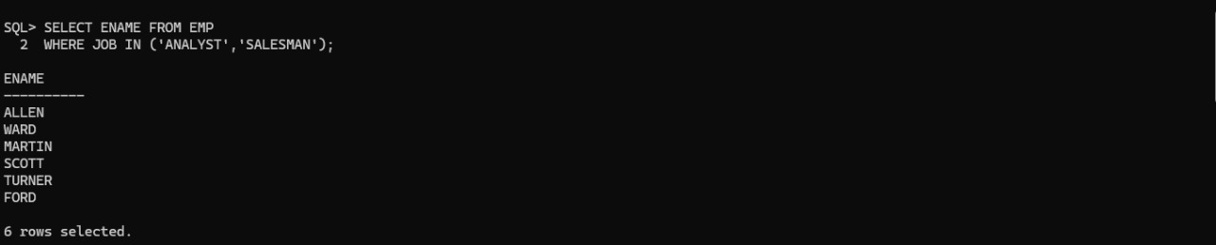

List details of employees who have joined before 30 Sep 81.

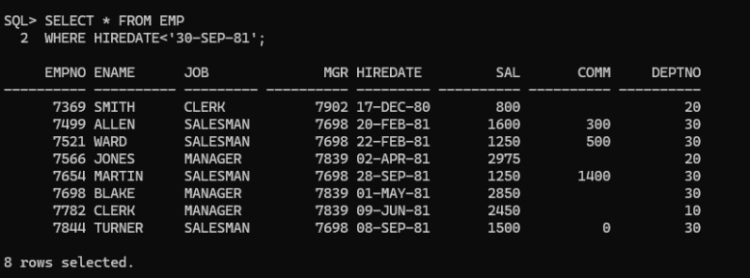

List names of employees who are not managers.

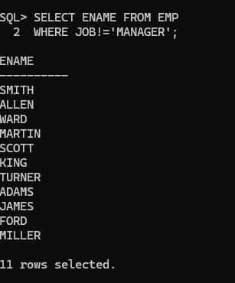

List the names of employees whose employee numbers are 7369, 7521, 7839, 7934, 7788.

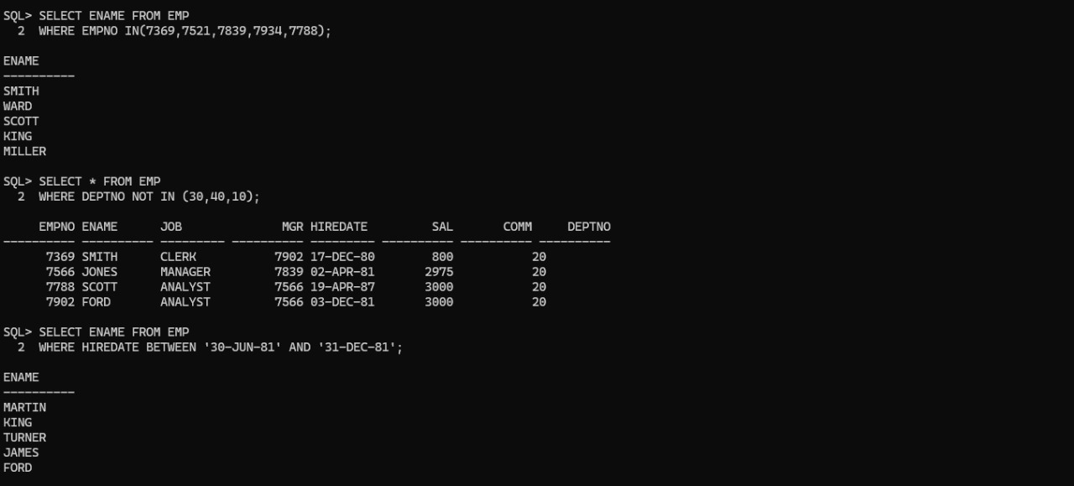

List employees not belonging to department 30, 40 or 10.

List employee names for those who have joined between 30 June and 31 Dec. ‘81.

List the different designations in the company.

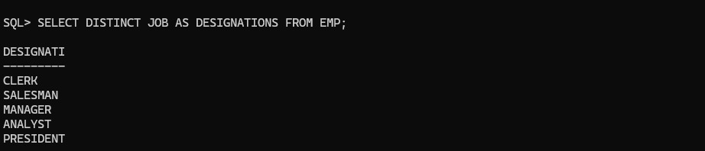

List the names of employees who are not eligible for commission.

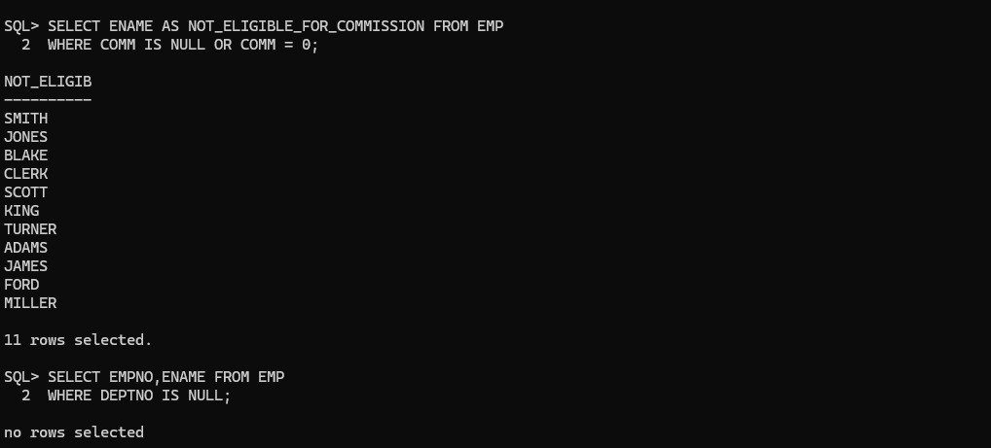

List the employees not assigned to any department.

List the employees who are eligible for commission.

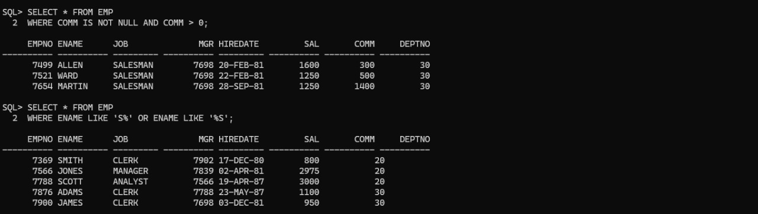

List employees whose names either start or end with “S”.

List names of employees whose names have “i” as the second character.

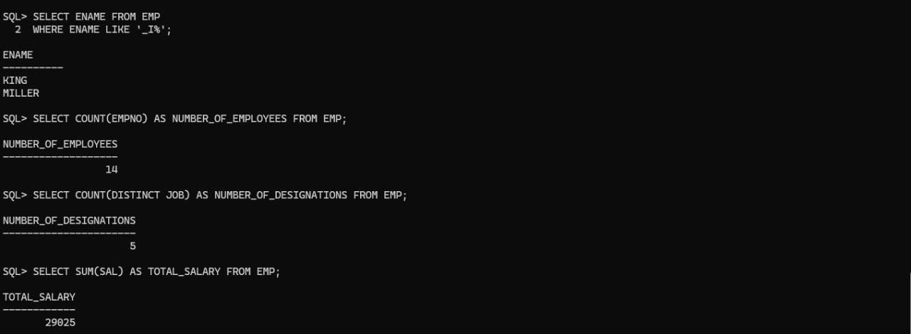

List the number of employees working with the company.

List the number of designations available in the EMP table.

List the total salaries paid to the employees.

List the maximum, minimum and average salary in the company.

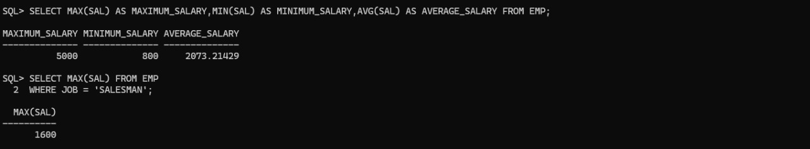

List the maximum salary paid to a salesman.

